Lunaspa Wash&Co

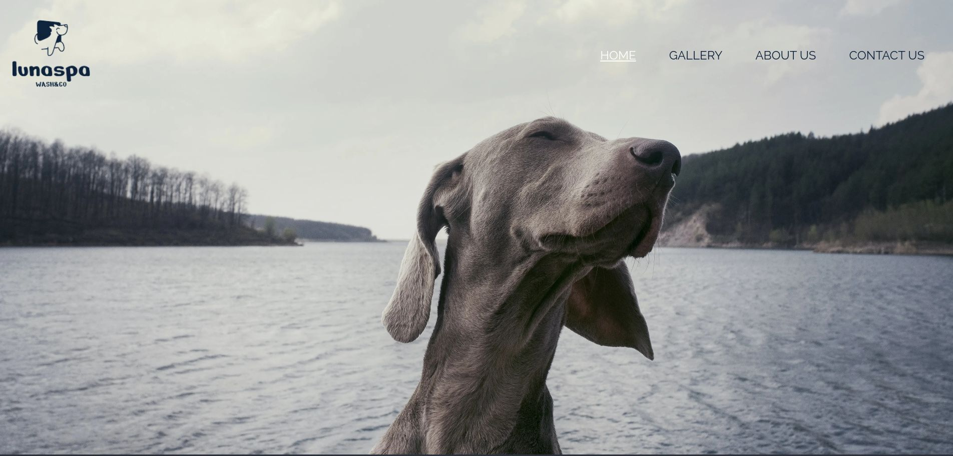
https://lunaspa.netlify.app/

Guilherme Grande (Student ID: 22233555)
Alexandru Georgescu (Student ID: 23124091)
Submitted to: Hamilton Niculescu
Saturday 02nd of December 2023
Table of Contents

- Executive Summary 1
- Project Work 2
- Design Process 3
- Testing & Responsiveness 6
- Conclusion 8
- References 9

To update table of contents, right click, update field, then update entire table.
- Executive Summary

Our team tackled a number of relevant topics and among them the one we saw with great potential and a growing market was pet services. After some research, we highlight some news and figures from the sector:

Bloomberg (2023) Global Pet Industry To Grow To $500 Billion By 2030, Bloomberg Intelligence Report Finds. Available at: https://www.bloomberg.com/company/press/global-pet-industry-to-grow-to-500-billion-by-2030-bloomberg-intelligence-finds/ [Accessed 16 November 2023]
Future Market Insights (2023) Europe Pet Care Products Market Outlook (2023 to 2033). Available at: https://www.futuremarketinsights.com/reports/europe-pet-care-products-market [Accessed 16 November 2023].
In the process, we have taken the path of offering a more personalised service where clients can choose from different types of services to suit their needs. Our services aim to reach the market of people who are looking for easy, high-quality pet care services.
During the elaboration of the project, the aspects for the final result to respect a good UX (User experience) and UI (User interface) behavior were taken into consideration, thus delivering a quality project where the user can easily understand the service offered on the company's website and can navigate between the pages intuitively.

The site must be responsive and accessible to multiple devices to serve the public efficiently and not fail to serve the market regardless of where the site is accessed.

Link deployed website:

https://lunaspa.netlify.app/

- Project Work

Our team worked together on multiple tasks and we divided the responsibility for the pages between the two members. Alexandru was responsible for the Home (index.html) and Gallery (gallery.html) pages while Guilherme designed the About Us (aboutus.html) and Contact (contact.html) pages.

Milestone | Deliverables | Responsable
Planning and design | Wireframes and Mockups. | Alexandru and Guilherme
Structure Development | Initial HTML structure for all pages (Head, header and footer). | Alexandru and Guilherme
Front-End Development | Create style.css file and insert the style for element, id and classes. | Alexandru and Guilherme
Content Creation | Elaborate the content (text) for the pages | Alexandru and Guilherme
Index Page - Java Script minigame | Create a mini game using JS. | Alexandru
Gallery Page - Java Script effect | Create an effect to display a text when user click in the image | Alexandru
About Us Page - Java Script reveal | Create a reveal move for the cards when scroll the page | Guilherme
Contact Page - Java Script and jQuery form | Add function to show/hide inputs for address. Add function to able/disable input for other pet. | Guilherme
Responsive - Media queries | Add media query for all the pages for a responsive website. | Alexandru and Guilherme
Website deployment | Prepare files for deployment and put website on live. | Alexandru
Review HTML/CSS/JS code | Review all code looking for errors and pass throw validators. | Alexandru and Guilherme
Testing website | Testing website functionality, responsiveness and response in multiple browsers. | Alexandru and Guilherme

- Design Process

Wireframes

All the pages will have the same header and footer.

The Home page wireframe was designed to have 2 sections of introduction alternating with an image. The mini game and the review section.

The Gallery page we decided to keep it simple and place four images. Two in the first row and two in another row.
Each photo will have a hover and click animation that, on click, will display a title and subtitle for each type of service that we offer.

The About Us page was designed with the purpose of having an introduction and to follow the journey of the company. We also mention a list of services/motivations that we use four our services.
At the end a short text with an image to call the user to contact us.

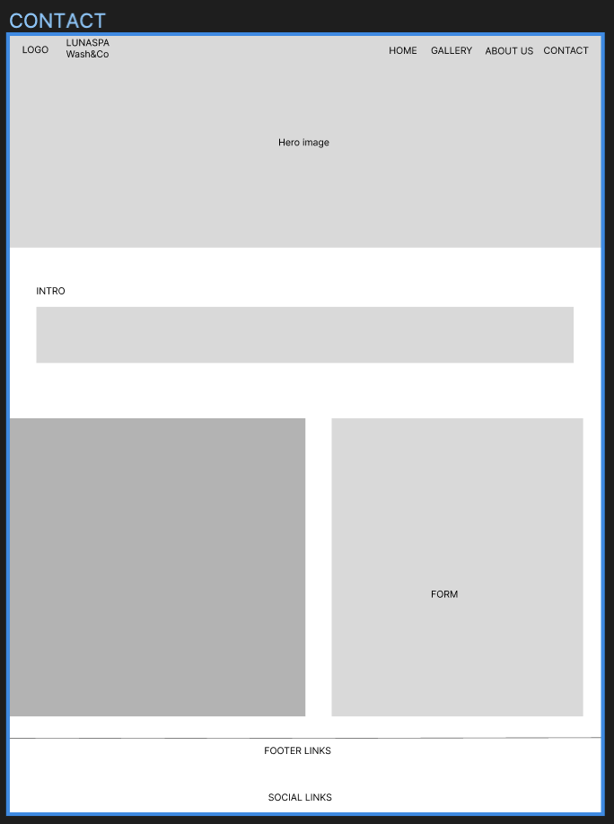
The Contact page was made as simple as possible so that the user won’t spend any unnecessary time that could drive him away from filling in the form.

Mood board

Typography

The website's font was chosen from google fonts. In this project we decided to use the fonts below.
- Raleway
- Poppins
- Montserrat

We considered that the fonts mentioned above are best suited for our project.

Colour scheme

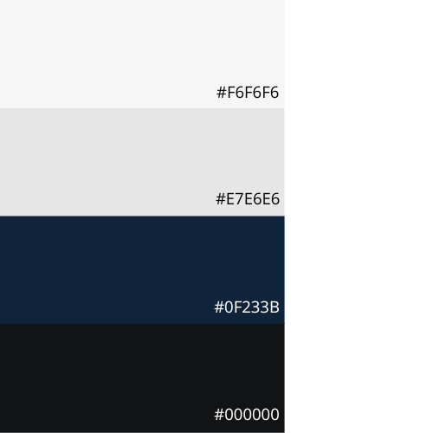

We used the colours in the palette above. We decided to use only the dark blue color as the main color and the other colours (gray and light gray) as the background and the black color for most of the texts.
Imagery

To increase the visual response of the website we selected some images related to the our services/theme. The images for the website were acquired from Unsplash.
We focus on using images where the animals are enjoying the moment or relaxing. To try to convey to the user how their companion will feel after our services. It’s also a must that we use high quality images so that we make the user experience as best as possible.

- Testing & Responsiveness

Talk about website responsiveness here along with Optimisation, SEO and Testing. You can talk about how you made your website responsive. You could also mention how you used JavaScript: loops, if statements, etc. How you deployed your website?

- Code validation
We used the following validator to check our code and apply the necessary fixes.

- HTML (https://validator.w3.org/)
The output result after all reviews: No errors
HTML code validated and respecting the good practices.

+SCREENSHOTS
- CSS (https://jigsaw.w3.org/css-validator/)
The output result after all reviews: No errors
CSS code validated and respecting the good practices.

+SCREENSHOTS

- Java Script (https://jshint.com/)
The output result after all reviews: No errors
Java Script code validated and respecting the good practices.

+SCREENSHOTS

- Browser validation
We tested the live website in the multiple browsers to check if the functionalities are working properly. Below are some screenshots with comments.

iOS Safari
Google Chrome
Mozilla Firefox
Microsoft Edge

+SCREENSHOTS

- Responsive testing
For the responsive testing we used the Google Inspect mode and switch the device models and also used the responsive dimensions to evaluate if the website are full responsive. Below few screenshots and comments with our opinions.

+SCREENSHOTS

- Optimisation testing
For the optimisation testing we used the Google Lighthouse report to evaluate the website score. We analysed (for all 4 pages) the following parameters: Performance, Accessibility, Best Practices and SEO.

+SCREENSHOTS

- Conclusion

Overview of how the project went, did you work together well as a team? What was difficult to do, how you feel the website looks and if you had time, would you make any changes?

- References

Finance, B. &., 2015. Flexible working worth €2.5bn to Irish economy. [Online]
Available at: http://businessandfinance.com/news/flexible-working-worth-e2-5bn-to-irish-economy/
[Accessed 8 March 2023].

